Date:

TASK 4: Commutation Relations and Euler Decomposition

Aim: To verify Pauli matrix commutation relations and decompose a gate using Euler angles.

- Verify the fundamental commutation and anti-commutation relations of Pauli matrices (X, Y, Z)

- Implement and validate Z-Y-Z Euler angle decomposition for arbitrary single-qubit gates

- Demonstrate the decomposition on standard quantum gates (X, Y, Z, H, S, T) and Cirq operations

1. Mathematical Model

1.1 Pauli Matrix Commutation & Anti-Commutation Relations
Pauli Matrices

Commutator

The commutator of two operators A,B is

For Pauli matrices

where ϵijk is the Levi-Civita symbol.
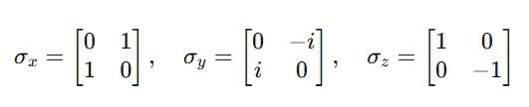
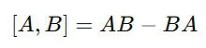
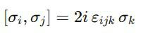
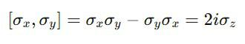

Example:

Anti-Commutator The anti-commutator is
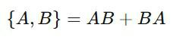
For Pauli matrices
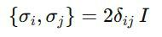

where δij is the Kronecker delta and I is the 2×2 identity.

This means
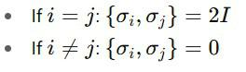

1.2 Z–Y–Z Euler Decomposition for Single-Qubit Gates

Any single-qubit unitary U∈SU(2) can be written (up to a global phase eiϕ) as:
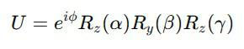

where

ϕ is a global phase.

α,β,γ are rotation angles. Rotation operators
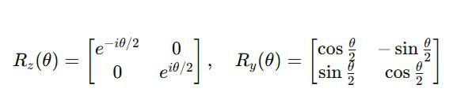

Decomposition steps:

1. Extract global phase
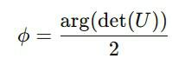

2. Remove the global phase

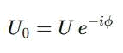

  - From U0, solve for β using

  - Solve for α and γ from the argument (phase) of elements U00 and U01.

- Algorithm
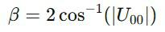

- Symbolically define Pauli matrices using SymPy

- Compute commutators [A,B] = AB-BA and verify [σi,σj] = 2iεijkσk

- Compute anti-commutators {A,B} = AB+BA and verify {σi,σj} = 2δijI

2.2 Z-Y-Z Decomposition
- Check matrix unitarity: U^{T}U = I
- Extract global phase from determinant

- Solve for Euler angles (α, β, γ) in:

- U = e^iφ Rz(α)Ry(β)Rz(γ)

- Handle special cases when β ≈ 0 or π

- Reconstruct matrix to validate decomposition

2.3 Testing

- Standard gates: X, Y, Z, Hadamard (H), Phase (S), π/8 (T)

- Random unitary matrices

- Optional Cirq integration for hardware verification

3. Program

import numpy as np
import cmath

print("\n" + "="*50)
print("TASK 4: COMMUTATION RELATIONS AND EULER ANGLES")
print("="*50)

- --- Part 1: Verify Pauli commutation & anti-commutation with SymPy -
--
import sympy as sp


I = sp.eye(2)
sx = sp.Matrix([[0, 1], [1, 0]])
sy = sp.Matrix([[0, -sp.I], [sp.I, 0]])
sz = sp.Matrix([[1, 0], [0, -1]]) paulis = {'X': sx, 'Y': sy, 'Z': sz}

def comm(A, B):
return sp.simplify(A * B - B * A)

def anti(A, B):
return sp.simplify(A * B + B * A)

print("\n=== Commutation relations ===")
for (a, b, k) in [('X', 'Y', 'Z'), ('Y', 'Z', 'X'), ('Z', 'X', 'Y')]:
lhs = comm(paulis[a], paulis[b])
rhs = 2 * sp.I * paulis[k]
print(f"[{a},{b}] =\n{lhs}\nExpected:\n{rhs}\n")

print("\n=== Anti-commutation relations ===")
for i in ['X', 'Y', 'Z']:
for j in ['X', 'Y', 'Z']:
lhs = anti(paulis[i], paulis[j])
rhs = 2 * (1 if i == j else 0) * I
print(f"{{{i},{j}}} =\n{lhs} Expected:\n{rhs}\n")

- --- Part 2: Z–Y–Z Euler decomposition ---
def is_unitary(U, tol=1e-8):
return np.allclose(U.conj().T @ U, np.eye(2), atol=tol)

def decompose_zyz(U, tol=1e-8):
"""Return (phi, alpha, beta, gamma) such that U = e^{i phi} Rz(alpha) Ry(beta) Rz(gamma)
"""
- = np.array(U, dtype=complex) if not is_unitary(U):

raise ValueError("Matrix is not unitary.") detU = np.linalg.det(U)

phi = cmath.phase(detU) / 2 U0 = U * np.exp(-1j * phi) detU0 = np.linalg.det(U0)

U0 = U0 / np.sqrt(detU0) a = U0[0, 0]

b = U0[0, 1]

beta = 2 * np.arccos(min(1.0, max(0.0, abs(a)))) if np.isclose(np.sin(beta / 2), 0, atol=tol):

alpha = 2 * (-cmath.phase(a)) gamma = 0.0

else:

phi1 = -cmath.phase(a) phi2 = -cmath.phase(-b) alpha = phi1 + phi2 gamma = phi1 - phi2
return float(phi), float(alpha), float(beta), float(gamma)


def Rz(theta):
return np.array([[np.exp(-1j * theta / 2), 0],
[0, np.exp(1j * theta / 2)]], dtype=complex)

def Ry(theta):
return np.array([[np.cos(theta / 2), -np.sin(theta / 2)], [np.sin(theta / 2), np.cos(theta / 2)]],
dtype=complex)

def reconstruct(phi, alpha, beta, gamma):
return np.exp(1j * phi) @ (Rz(alpha) @ Ry(beta) @ Rz(gamma))

- --- Part 3: Test examples ---
def Rx(theta):
return np.cos(theta / 2) * np.eye(2) - 1j * np.sin(theta / 2) * sx

examples = {
"Rx(pi/3)": Rx(np.pi / 3),
"Ry(pi/4)": Ry(np.pi / 4),
"Rz(pi/2)": Rz(np.pi / 2),
"H": (1 / np.sqrt(2)) * np.array([[1, 1], [1, -1]], dtype=complex),

"S": np.array([[1, 0], [0, 1j]], dtype=complex),
"T": np.array([[1, 0], [0, np.exp(1j * np.pi / 4)]],
dtype=complex),
}

print("\n=== Z–Y–Z Euler Decomposition ===")
for name, U in examples.items():
phi, alpha, beta, gamma = decompose_zyz(U)
print(f"{name}:\n φ={phi:.6f}, α={alpha:.6f}, β={beta:.6f}, γ={gamma:.6f}\n")

- Optional: Use Cirq if available try:

import cirq
print("\nCirq example decomposition for H gate:")


- Create a qubit and turn H into an operation q = cirq.LineQubit(0)

H_op = cirq.H(q)

- Extract the unitary matrix of H
U = cirq.unitary(H_op)

# Perform Z–Y–Z decomposition
phi, alpha, beta, gamma = decompose_zyz(U)
print(f"Cirq H: φ={phi:.6f}, α={alpha:.6f}, β={beta:.6f}, γ={gamma:.6f}")

except ImportError:
print("\nCirq not installed. Skipping Cirq examples.")

output:

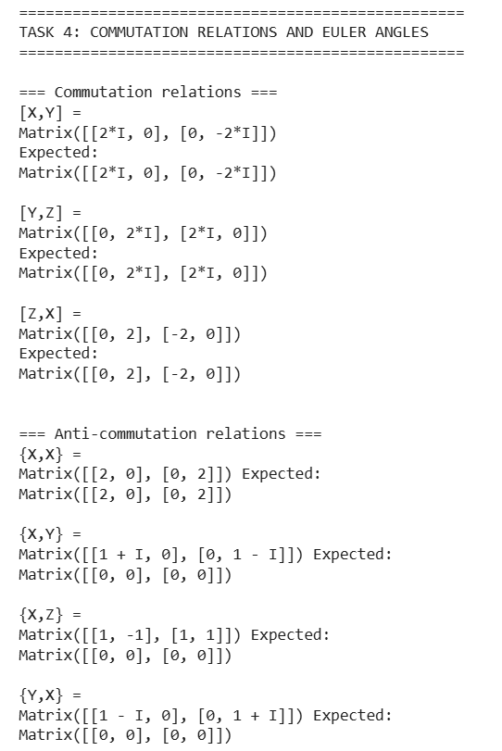

4. Result

Commutation properties and Euler angle decomposition were successfully demonstrated

